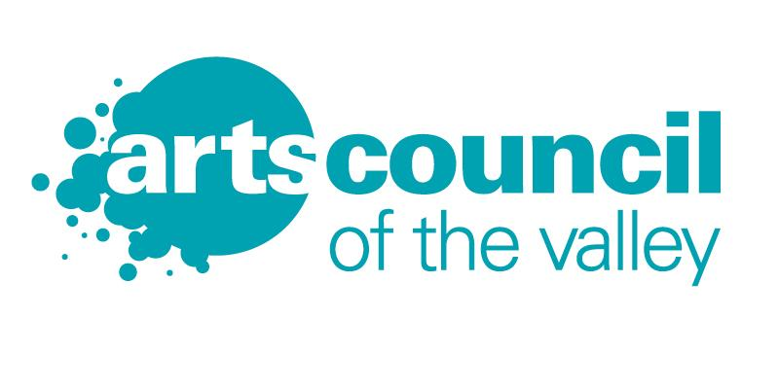 | 311 South Main Street  Harrisonburg, VA 22801  540.801.8779  jenny@valleyarts.org | ADVANCING  THE ARTS  GRANT  FINAL REPORT

Final Report due dates:
Spring Cycle Grants - November 1 by 5 pm
Fall Cycle Grants - June 1 by 5 pm

If the completed Final Report is not submitted on time, the Grantee forfeits in whole or part of the amount of the final installment, at the discretion of ACV. If the Grantee requires an extension for the Final Report, a written request must be submitted no later than two weeks before the due date. A written explanation for the extension must be included in the request. The Grantee will be notified the decision of the Grants Committee within one (1) week. An incomplete Final Report or an untimely submission, absent an approved extension, will preclude Grantee’s eligibility for current and/or future ACV funding.

Please copy and paste the following information into a new document and provide the required information in the order specified below. Please title all pages “Spring 2019 Final Report Form” with the name of your organization. Reimbursement of the final 25 percent (25%) of the grant award is conditional upon a timely, fully completed, and satisfactory final report.

Final Report Form

GRANT CYCLE: ❑ FALL ❑ SPRING YEAR ___________
Click here for Grant Cycle Submission Timeline

GRANT TYPE: ❑ Arts For Education ❑ Creative Inspiration

- Grantee name, address, telephone, and e-mail:

- Title of project:
- Project start date and project end date:
- Based upon the information given in your application, please provide a detailed report on the success of your project. Explain how your organization has evaluated the project. Do you plan to repeat the project next year, or make changes? If so, what changes, if any, will you make to improve the project’s outcome? What new relationships have you established as a result of the project?
- Explain the value of Arts Council of the Valley’s grant in carrying out your project.
Has the grant been useful in your efforts to raise additional funds and/or attract
audiences or participants?

- Provide a final budget report, in the format specified in your original grant application, comparing actual numbers to budgeted amounts. Explain any significant changes. You should account for 100% of the grant award in your budget, recognizing that the final 25% payment is made on a reimbursement basis.
- Total number of participants in this project, including attendance. Provide actual numbers where available, or reasonable estimates, of the breakdown between City of Harrisonburg and County of Rockingham participants. Suggested format:
City of Harrisonburg = XX
Rockingham County = XX
Other = XX
Grand total participants = XX
- Please type the statement “To the best of my knowledge, the information contained in this report is true and accurate.” Below this statement, please type the name, title, and daytime phone number of the person reporting. Provide an original signature below.
- Attach any printed materials, press clippings, programs, reviews, evaluation forms, brochures, etc. related to the funded project. Please highlight recognition of Arts Council of the Valley support in materials that you produced. In addition, please submit 3-5 high quality digital photos of your event to Jenny@valleyarts.org
- Attach original receipts (or copies) for the total amount of the grant award to substantiate your reimbursement request for the grant award. Only receipts pertaining to the use of the grant are necessary.

FINAL GRANT REPORT MUST BE RECEIVED BY ACV NO LATER THAN 5 PM ON THE DUE DATE (November 1 for Spring Cycle Grants; June 1 for Fall Cycle Grants).

Final reports may be emailed (preferred) to advancingvalleyarts@gmail.com or
mailed/hand-delivered to:
Arts Council of the Valley, 311 South Main Street, Harrisonburg VA 22801

